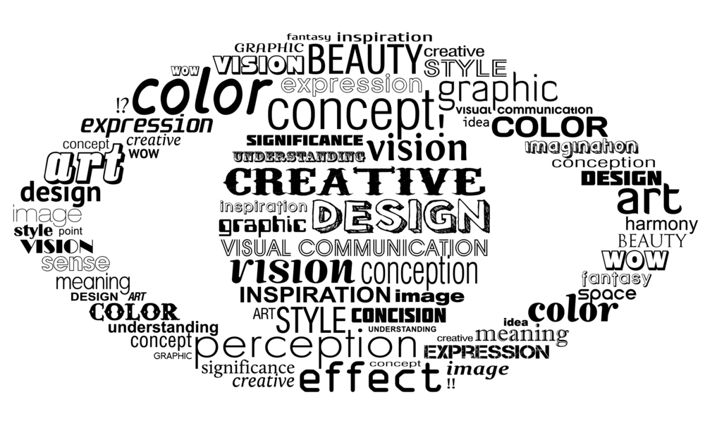

Visual Learners
Always have the "big picture" in front of you
A topic overview should be used, especially when studying its parts or details.
Organise your notes with the big picture in mind
Organising might involve ordering or colorings to suit the topic overview
When trying to remember things,
close your eyes to get a picture or image of the information.
Once you understand something,
practice applying the information in place of repeating facts.
Use mind maps
Instead or written outlines, use mind maps to organize, to visualize ideas, connections, sequences, and conclusions. Brainstorm using illustrations, mind maps and models.
Organise your study space
remove distractions, and use posters and notes to remind you.
Illustrate your notes
with images, graphs and diagrams.
Use color
This might be highlighters or coloured pens for notes. Use different coloured paper for different subjects or topics.
Look pictures or videos covering the things you are studying
Videos, overheads and PowerPoint demonstrations, graphs, maps, and media programs.

