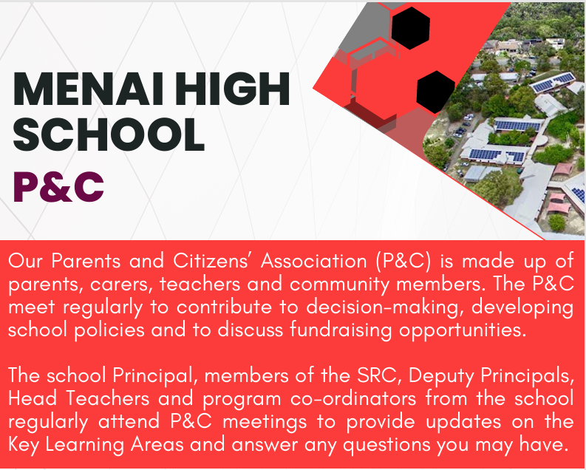



**2025 MEETING TIMETABLE**

10February – Annual General Meeting

10March

12May

11 August

8 September

13 October

10 November

8 December

Scan QR code for more information about the MHS P&C

