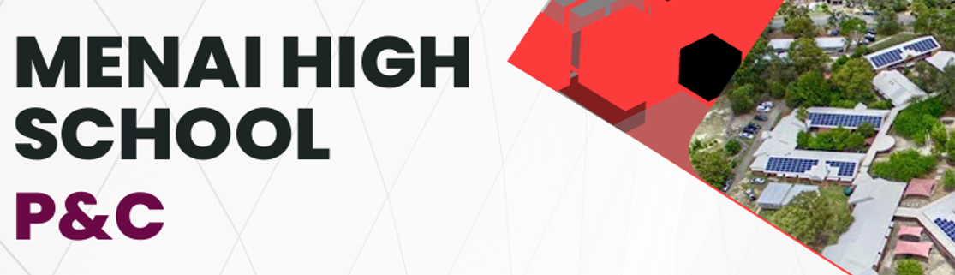

**MERIT SELECTION PANELS**

The NSW Department of Education uses merit selection panels to determine the successful candidate for certain positions in public schools. Merit selection panels are formed to select applicants for advertised classroom teachers, principals, and executive positions.

The role of the panel is to recommend the most suitable applicant to fill a vacant position based on the extent to which they meet the criteria for the position. The selection panel must include a **parent representative** nominated by the School P&C Association.

To assist principals, directors, school community members, panel conveners, and other members of selection panels, the NSW Department of Education has prepared a suite of e-learning material. Parent representatives must complete the online selection panel training to be eligible to participate in the section panel.

Currently, there are limited numbers of P&C members who are panel trained (less than a handful), so it is important that other people also volunteer to complete the training and participate in selection panels and other decision-making opportunities for the school.

**Any parent, grandparent, uncle, aunty, etc, or member of the school community can undertake the training and participate in the selection panel process**. There will be ongoing staff recruitment needs at the school and every panel requires a parent representative to assist as a panel member.

To complete the training please search for ‘merit selection panel training’ on the NSW Department of Education website or use the following link - *https://education.nsw.gov.au/about-us/careers-at-education/employment-opportunities/ participate-on-a-selection-panel*

If you have recently completed the selection panel training or are planning to do so, please inform the School Principal, Mr Stanley. For more information and any queries, please reach out the MHS P&C President [mhs.pandc.president@gmail.com](mailto:mhs.pandc.president@gmail.com)