**CORRECT SCHOOL SHOES**

**Leather or Suede fully enclosed non-porous shoes**

**Shoes must be entirely black. No white rimmed soles or prominent white emblems/signs.**

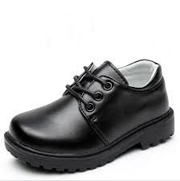 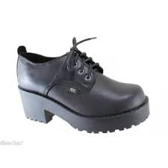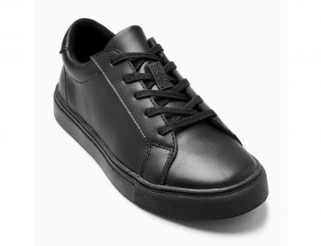[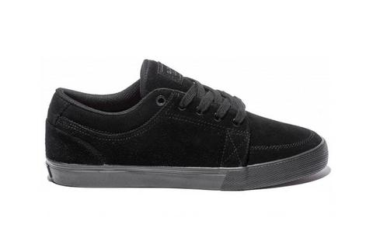](http://www.google.com.au/url?sa=i&rct=j&q=&esrc=s&source=images&cd=&cad=rja&uact=8&ved=0ahUKEwiK-NaW2YnUAhXGjJQKHYzZAIwQjRwIBw&url=http://deckedout.com.au/collections/vendors?q%3Dglobe&psig=AFQjCNENSaISFeirohxmC2QYRuZ-zAFARQ&ust=1495754767570481)[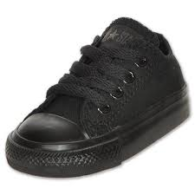](https://www.google.com.au/imgres?imgurl=http://i.ebayimg.com/00/s/NTAwWDUwMA%3D%3D/z/0RMAAOxycD9TRRNL/$_32.JPG&imgrefurl=http://www.ebay.com/gds/A-Guide-to-Buying-Chuck-Taylor-Converse-Shoes-for-Kids-/10000000178448030/g.html&docid=Hd-N1zRESI7twM&tbnid=TFkqNtkBgMI-rM:&vet=10ahUKEwj67umI74nUAhUEoZQKHSBTDqIQMwhyKEQwRA..i&w=500&h=500&safe=strict&bih=835&biw=898&q=converse%20school%20shoes&ved=0ahUKEwj67umI74nUAhUEoZQKHSBTDqIQMwhyKEQwRA&iact=mrc&uact=8)

**INCORRECT SCHOOL SHOES**

**Not to be worn to school under any circumstances**[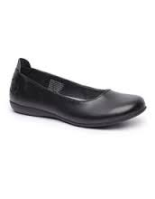](https://www.google.com.au/imgres?imgurl=https://www.numberoneshoes.co.nz/content/products/medium/anna-school-shoes-anna-school-black-imagehero.jpg?1480452279&imgrefurl=https://www.numberoneshoes.co.nz/product/maria-buckle-school-shoes-girls-23374973&docid=EGx8QRF4vuTCsM&tbnid=NA0AYtJosPFX9M:&vet=10ahUKEwi-kfuj2onUAhWMI5QKHZbNArM4ZBAzCBwoGjAa..i&w=215&h=275&safe=strict&bih=835&biw=898&q=INCORRECT%20SCHOOL%20SHOES&ved=0ahUKEwi-kfuj2onUAhWMI5QKHZbNArM4ZBAzCBwoGjAa&iact=mrc&uact=8)[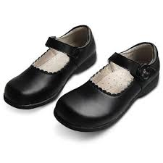](https://www.google.com.au/imgres?imgurl=http://p.globalsources.com/IMAGES/PDT/B1043873147/Girls-School-Shoes.jpg&imgrefurl=http://www.globalsources.com/manufacturers/School-Shoes.html&docid=pfYtw728zq_6JM&tbnid=g1MnPRpVABG_KM:&vet=1&w=360&h=360&safe=strict&bih=835&biw=898&ved=0ahUKEwiYq9mW2onUAhVCipQKHYVaDukQMwhWKCgwKA&iact=c&ictx=1)[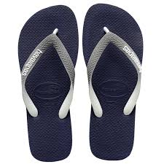](https://www.google.com.au/imgres?imgurl=http://d3d71ba2asa5oz.cloudfront.net/62000804/images/zz260243g_2.jpg&imgrefurl=http://www.ebay.com/itm/Womens-Havaianas-Top-Mix-Brasil-Rubber-Beach-Thongs-Flip-Flops-Slip-On-US-4-11-/361245557155&docid=ccB333ZtHSZsVM&tbnid=Bvts3oPsZTON-M:&vet=10ahUKEwinxJju44nUAhXCkZQKHbIIDpsQMwiHAShdMF0..i&w=1301&h=1301&safe=strict&bih=835&biw=898&q=havaiana%20thongs&ved=0ahUKEwinxJju44nUAhXCkZQKHbIIDpsQMwiHAShdMF0&iact=mrc&uact=8)[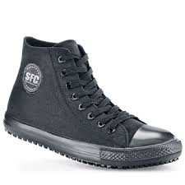](https://www.google.com.au/imgres?imgurl=https://s-media-cache-ak0.pinimg.com/originals/55/e7/d4/55e7d49cfbe5da3addf7b55dbb44c1a7.jpg&imgrefurl=https://www.pinterest.com/pin/191895634096600456/&docid=_hsj7K4GzCm-2M&tbnid=sWIAgKymWUlFDM:&vet=10ahUKEwibj5uX5YnUAhUDGpQKHfZHBI04ZBAzCAcoBTAF..i&w=350&h=350&safe=strict&bih=835&biw=898&q=canvas%20school%20shoes&ved=0ahUKEwibj5uX5YnUAhUDGpQKHfZHBI04ZBAzCAcoBTAF&iact=mrc&uact=8)[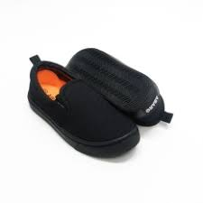](https://www.google.com.au/imgres?imgurl=http://my-live-01.slatic.net/p/7/abaro-school-shoes-new-2326-black-canvas-pre-schoolprimaryschool-unisex-0891-89110951-141ce41cd3f6f3d7e0846004b04468ed-catalog_233.jpg&imgrefurl=http://www.lazada.com.my/girls-shoes/abaro/&docid=yw43uVVtPAeU3M&tbnid=aHPcwdlBXRQx5M:&vet=10ahUKEwikmbGm5YnUAhXIk5QKHT5VAd04yAEQMwhPKEowSg..i&w=233&h=233&safe=strict&bih=835&biw=898&q=canvas%20school%20shoes&ved=0ahUKEwikmbGm5YnUAhXIk5QKHT5VAd04yAEQMwhPKEowSg&iact=mrc&uact=8)[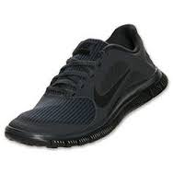](https://www.google.com.au/imgres?imgurl=http://web.stemiliescps.wa.edu.au/wp-content/uploads/2015/12/black-sandshoe.jpg&imgrefurl=http://web.stemiliescps.wa.edu.au/?p%3D13334&docid=HiXTMD8TcV2CWM&tbnid=uHwlrf8WhHPntM:&vet=10ahUKEwiK5dDV6YnUAhXCjZQKHRRfBl4QMwhIKBowGg..i&w=236&h=236&safe=strict&bih=835&biw=898&q=correct%20school%20shoes&ved=0ahUKEwiK5dDV6YnUAhXCjZQKHRRfBl4QMwhIKBowGg&iact=mrc&uact=8)