MENAI HIGH SCHOOL

HIGHER SCHOOL CERTIFICATE ASSESSMENT BOOK
2018 AND 2019

Principal Mr B Ellevsen
Deputy Principal (Year 12) Mrs R Allen
Deputy Principal Mrs E Sayed-Rich
Deputy Principal Mr L Meagher

40 Gerald Road | Telephone: | 9543 7000
Illawong NSW 2234 | Fax: | 9543 5513

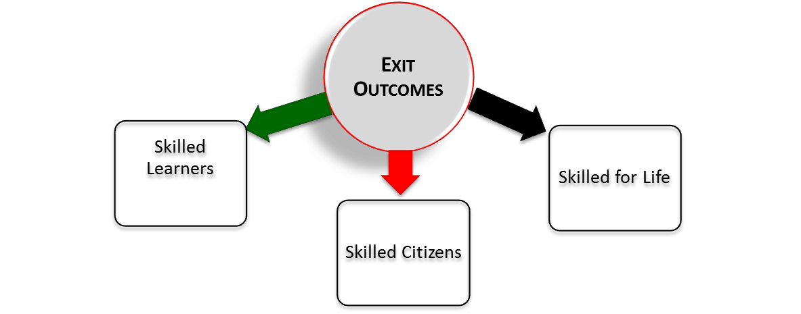

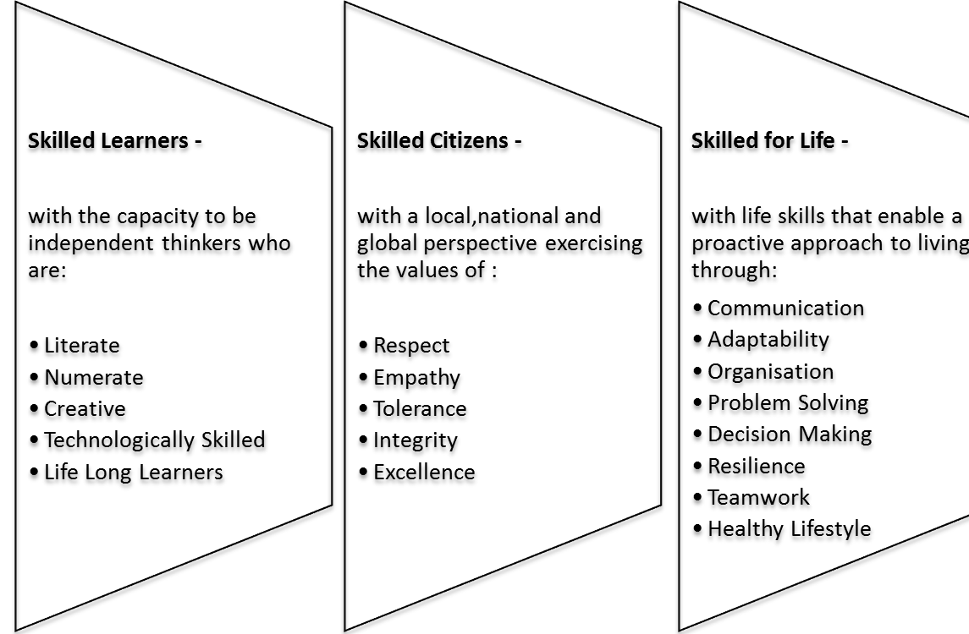

THE REQUIREMENTS OF THE EDUCATION ACT 1990 AND AS PRESCRIBED BY NESA IN RELATION TO NEW SOUTH WALES HIGHER SCHOOL CERTIFICATE
To be eligible for the award of the Higher School Certificate students must:
- have gained the ROSA or such other qualifications as NESA considers satisfactory;
- have attended a government school (or accredited non-government school);
- have satisfactorily completed courses that comprise the pattern of study required by NESA for the award of the High School Certificate;
- sit for and make a serious attempt at the requisite Higher School Certificate external examinations.

Patterns of study
To qualify for the Higher School Certificate Year 11, 2017 and Year 12, 2018 students must satisfactorily complete a preliminary pattern of study comprising at least 12 units and an HSC pattern of study comprising at least 10 units. Both patterns must include:
- at least six units from Board developed courses;
- at least two units of a Board Developed course in English;
- at least three courses of two units value or greater (either Board Developed or Board Endorsed courses);
- at least four courses.
To satisfy pattern of study requirements for the High School Certificate a student may count a maximum of six Preliminary units and seven HSC units from courses in science (see Appendix 1).

Satisfactory Completion of a Course
The following course completion criteria refer to both Preliminary and HSC courses.

Course Completion Criteria
A student will be considered to have satisfactorily completed a course if, in the principal’s view, there is sufficient evidence that the student has:
- followed the course developed or endorsed by NESA; and
- applied themselves with diligence and sustained effort to the set tasks and experiences provided in the course by the school; and
- achieved some or all of the course outcomes.
Students who are frequently absent are in danger of not completing course requirements. “N” warning letters will be sent advising students and parents of the consequences.

Completion of course requirements in a VET course
As with all other HSC courses, students undertaking VET courses may be deemed to have either completed or not completed course requirements. It should be noted that if a student fails to undertake any mandatory work placement component it may be determined that the student has not made a genuine attempt to complete course requirements. In this case the principal can indicate that the course has not been satisfactorily completed and the student may be eligible for an “N” determination.
If at any stage a student appears to be at risk of receiving an “N” determination in a VET course the principal will send “N” warning letters.

Assessment of VET courses
Assessment in all VET courses is competency based. The student is assessed on what they can do (the skills) and what they know (the knowledge) that will equip them in the workplace. Students who have successfully achieved competency will have the skills and knowledge they need to complete workplace activities in a range of different situations and environments, to an industry standard of performance that is expected in the workplace.
Competency-based training is based on performance standards that have been set by industry. Thus, a student’s performance is judged against this standard, not against the performance of other students.
Students will receive documentation showing the competencies achieved for the VET course undertaken. A student will be judged as either competent or not yet competent.

ASSESSMENT AND REPORTING
The HSC report will provide a description of a student’s achievements. School-based assessment tasks will contribute to 50% of the student’s HSC mark. The school assessment mark will be based on a student’s performance in the assessment tasks undertaken during the course.
The other 50% will come from the HSC examination.
HSC marks for 2 unit courses will be reported on a scale of 0 to 100. A mark of 50 will represent the minimum standard expected. If a student achieves the minimum standard expected in a course he or she will receive a mark of 50. There will be five performance bands above 50 that correspond to different levels of achievement in knowledge, skills and understanding. The band from 90-100 will correspond to the highest level of achievement.
On satisfactory completion of the HSC a student will receive a portfolio containing:
- The HSC Testamur (The official certificate confirming a student’s achievement of all requirements for the award).
- The Record of Achievement (This document lists the courses studied by a student and reports the marks and bands that student has achieved).

Course Reports.
For every HSC Board Developed Course a student will receive a Course Report showing his or her marks, the Performance Scale and the band descriptions for that course.

The Australian Tertiary Admissions Ranking (ATAR)
The requirements for the Australian Tertiary Admissions Ranking are determined by the universities. The ATAR is calculated by the Universities’ Technical Committee on Scaling on behalf of universities in NSW and the ACT. A candidate’s ATAR is calculated from the scaled aggregate of the marks in the best ten units in Board Developed HSC courses, course to the following restrictions:
- At least two units of English must be included;
- At least three Board Developed courses of two units value or greater must be included;
- Courses from at least four courses must be included;
- 8 Units of Category A (Board Developed Courses) and at most, two units of category B courses may be included in the calculation of the ATAR.
[Note: Students wishing to have an ATAR calculated must indicate this on their HSC entry form. Students who do not meet the above requirements will not be eligible for an ATAR].

The Category B courses are:
- Construction (240 hours)2
- Entertainment Industry (240Hours)2
- Information and Digital Technology (240 hours)2
- Primary Industries (240 hours)2
- Hospitality Operations (240 hours)2
- Business Services (240 hours)2

WHAT IS HSC ASSESSMENT?
HSC Assessment is a mark gained by students in each of their HSC courses, based on their performance on set Assessment Tasks during those courses.
The final mark submitted as the Assessment is defined as:
“The mark for each student studying a Board course which represents a measure of the student's achievement relative to other students by the end of the course in Year 12.”
The Assessment will be based on achievements measured throughout the course. It will encompass all syllabus objectives other than those relating to the affective domain.

WHY IS ASSESSMENT NECESSARY?
The Assessment is intended to provide an indication of a student's attainment of a wider range of syllabus objectives than is measured by the single HSC examination, though it does cover all the objectives measured by the examination. The Assessment allows due weight to be given during the course to student achievement which although evident to the class teacher, may not be adequately assessed in a single external examination.

WHAT ARE ASSESSMENT TASKS?
These are the tasks used to assess a student in a particular aspect or aspects of a course and may include such things as major examinations, class tests, practical work, assignments, essays, oral presentations and other forms of class work.
These are marked to provide a rank order for students in a course.

WHAT IS INCLUDED IN THE ASSESSMENT?
Teachers are free to choose whichever tasks they feel are the best for assessing the various components and for discriminating between candidates. Assessment programs can include formal exams, assignments, tests, oral work, fieldwork, laboratory work, projects and so on. Some courses have a requirement that certain skills (e.g. oral skills) must be assessed. The Course Assessment schedule will outline.

HOW IS THE ASSESSMENT POLICY ESTABLISHED?
NESA runs the HSC provides guidelines in every course to schools. These guidelines are used by the school’s teachers to draw up an Assessment Program for students. Assessment Programs in any course will differ from school to school in terms of how the assessment is being carried out, but are the same in every school in terms of the areas of the syllabus that are being assessed and the weight placed on each component.
Faculty assessment policies will show the components and their weightings for each course.

WHEN DOES HSC ASSESSMENT START AND FINISH?
The Menai High School HSC Assessment Program will commence after the beginning of Term 4, Year 11 or the start of the HSC course. All HSC assessment tasks will be completed by the end of Term 3, Year 12, where possible.
Faculty assessment policies will show students approximately when the HSC assessment period begins and ends for that course, and the approximate timing for each assessment task.
At least two weeks' notice will be given for any task and it is the student's responsibility to report unduly onerous task loads immediately if they occur. This could include the scheduling of three tasks on the same day.

HOW WILL THE INTERNAL AND EXTERNAL MARKS COMBINE TO PRODUCE THE HSC MARK?
The internal assessment and the external examination will carry an equal weighting in the determination of the student’s HSC performance in the course.
The internal assessment marks and the marks on the external examination will be treated as follows:
- the course assessment marks submitted by the school will be moderated by the exam performance of the school group.
- the moderated assessment and the examination mark will be averaged to provide a composite mark.
- experienced markers will follow a structured procedure employing professional judgement to determine what composite marks will correspond to the borderline between each performance band. This step provides a set of ‘mapping points’ that enable student marks to be aligned with the performance scale.
- each student’s moderated assessment and examination mark are then separately aligned to the performance scale
- the average of a student’s assessment mark and examination mark, after alignment to the performance scale, is then reported as the student’s HSC mark.

WHAT ARE THE SCHOOL’S RESPONSIBILITIES?

Does a student have to be told anything?
Each faculty will issue students with an Assessment policy for each of its courses students take. The faculty policy will show:
- the components and their weightings as specified;
- an indication of when each of the assessment tasks will take place;
- the mark value of each task in relation to the total number of marks for the course;
- the nature of each assessment task (e.g. assignment);
- details of any special administrative arrangements associated with each task.
At least two weeks written notice will be given of the specific date and nature of any assessment task.
Students will also be told how well they did in each task, and on at least two occasions (when reports are issued) they will be told their ranking within the group undertaking each course.

All senior students will be provided with marking guideline criteria before each actual task is undertaken. All assessment tasks will contain a rubric (criteria to be addressed in the response) plus a list of outcomes tested. Teachers collaborate on the development of tasks and rubrics. Teachers employ marking procedures that ensure fairness. These procedures may include double marking, all tasks being marked by the same person or teachers dividing up papers to mark according to question.
All tasks should have access points and extension points for students. If the task is not modified for select students the task becomes null and void.
A major works is one task. Teachers can set check in times through informal assessment but not to the weighting of the task.

WHAT ARE A STUDENT’S RESPONSIBILITIES?
- Students must make a serious attempt at every HSC assessment task or a mark of zero will be recorded. Submitted work may be classified as a non-serious attempt where it is frivolous or offensive. Failure to reach a level of achievement does not necessarily constitute a non-serious attempt. Where the school applies a penalty for a frivolous or offensive response, the issue should be recorded on the malpractice register eg if a student only completes the multiple choice section of an examination. If the student is registered for malpractice on more than one occasion their HSC may be placed in jeopardy.
- Each student must complete the task by the time indicated on the calendar.
- All work presented for assessment must be student's own work. (If this is found out not to be the case), then a mark of zero will be given for that task and the student may be disqualified from that course if the task has not been redeemed. A situation of non-original work being submitted will see a mark of "0" being awarded. Students who are found to plagiarise will be registered with NESA for undertaking malpractice. An attempt to do tasks at school will overcome this problem wherever possible.
- Students should:
- allocate time to prepare for every test and assignment even though they may not count towards their final assessment.
- realise that all work done contributes to their skills and knowledge of the course which will help in assessment tasks.
- realise that good assessments may indicate that they are a reliable and/or conscientious student to a prospective employer.
- Students who are required or choose to use technology to present classwork/course work or assessment tasks students will need to ensure the work/task are saved in more than one place. Technology issues will not be an acceptable excuse.
A student's work must be consistent and of as high a standard as possible throughout the whole HSC course, in both assessment and non-assessment tasks. Non-assessment tasks must be completed for two reasons:
  - They prepare the student for assessment tasks.
  - If a student does not complete the non-assessment work related to the course, the student risks losing the principal's certification for his or her final HSC which shows acceptable participation and application in the course. This may lead to the student not being awarded this course at the HSC. It could also mean that the student is not eligible for an HSC because he or she does not have enough units. If the student’s attendance and application is unsatisfactory in Year 11, the student may not complete the required number of units in Year 11, and so may not be able to progress to Year 12.
A student may only query a mark for an assessment task at the time it is returned.

DOES A STUDENT HAVE TO DO THE ASSESSMENT TASKS?

Yes. A student who fails to complete 50% of the available marks will be regarded as not having satisfactorily completed the course of study. In cases of NON-SATISFACTORY completion, an "N" indicator will be submitted.
A student who does not comply with the assessment requirements in any course will have neither a moderated assessment mark nor an examination mark awarded for that course.
In the case of Extension courses, a student who fails to meet the assessment requirements for the co requisite 2 unit course will not receive a result in either course.

DOES A STUDENT ONLY HAVE TO COMPLETE ASSESSMENT TASKS?
No. A student is expected to complete coursework for all courses. All work set in a course is part of the HSC Curriculum regardless of whether it is assessable or not and it is examinable at the HSC. A student may also receive an N Warning letter for non-completion of classwork.

WHAT IS AN “N” OR A N DETERMINATION
A student who fails to complete 50% of the available assessment marks and these tasks have not been redeemed will be regarded as not having satisfactorily completed the course of study and will be awarded an N determination. A student may also receive N Warnings for non-completion of classwork. If the classwork tasks have not been redeemed the student will be regarded as not having satisfactorily completed the course of study and could be awarded an N determination.
In cases of NON-SATISFACTORY completion, an "N" indicator will be submitted to NESA.

WHAT SHOULD A STUDENT DO IF SENT AN N WARNING LETTER?
The assessment or course work needs to be done at the time. It is not to be redeemed at the end of the course. The school will go through the process of an N determination if the assessment or course work is not redeemed within a reasonable time frame.

WHAT IF A STUDENT DOES NOT HAND WORK IN ON TIME?
It is the responsibility of the student to be present for, or to hand in assessment tasks at the required time indicated on the assessment notification. The latest a task can be handed in, if time is not indicated on the assessment notification, is close of business (4pm on the due date). No allowances are made for late arrival of work. Technology issues will not be an acceptable excuse. A student will need to ensure the work/task is saved in more than one place. If no viable excuse is forthcoming and the policy below is not followed, then a mark of zero will be recorded and a non-attempt registered next to the student's name.

WHAT PERCENTAGE OF ASSESSMENT TASKS CAN A STUDENT USE AN ILLNESS/ MISADVENTURE APPEAL?
A student can only use an illness /misadventure appeal for a maximum of 40% of the assessment marks. Students must do 60% of assessment as true assessment. In extreme cases, which are supported by evidence/documentation, the principal may consider appeals to relax the 60% true assessment guidelines. A decision will be at the discretion of the Principal or the Principal’s representative.

WHAT HAPPENS IF A STUDENT IS ABSENT THROUGH ILLNESS OR MISADVENTURE?
If a student is absent for an assessable task, or fails to hand in a task on time, must inform the Head Teacher of that course by phone, fax or email on the day of the task. Failure to do so will result in a non-attempt being recorded for the task. The student when contacting the Head Teacher is to give an expected date for return to school. Evidence must be supplied to support the day/s absent from school and must be attached to the Illness/misadventure application. The Illness/misadventure review panel will consider all evidence from the school and the student and decide if the application is upheld or declined. The illness/misadventure panel consists of senior executive and executive members. In extreme circumstances a decision will be at the discretion of the Principal or the Principal’s representative.

If absent due to illness/misadventure, on the first day of return to school the student is to:
- See the Head Teacher to negotiate an alternative time or task.
- Be prepared to do the exam or assessment task or hand in the task on the first day of return to school.
- Collect a Menai High School illness misadventure form to complete and return to the Head Teacher the next day with appropriate documentation as evidence of the reason for their absence. A doctor's certificate is the only acceptable evidence in the case of illness. In the case of misadventure, written evidence from a parent/caregiver is required and in some instances, the school may request additional evidence. A medical certificate must be issued on the same date as the task.

The Illness / Misadventure panel will review the application.
- Failure to do the above steps will result in a non-attempt plus a mark of zero being recorded for that task.

NB: If the due date is the last day of term, the student must contact the Head Teacher that day and on the first day of return of the new term must see the Head Teacher of the subject and follow the above steps ( i to iv)

- If a student is absent from an assessment task due to work placement for a VET course or school representation he or she will do the task or an alternate task at a more suitable time. Work placement is a mandatory requirement for VET course.

What is the due date of the of illness misadventure application?
The application must be lodged within two days of returning to school. For example student returns Monday , the application must be lodged by close of business Wednesday.

WHAT HAPPENS IF A STUDENT IS ILL DURING THE EXAM OR CLASS TASK?

If a student is ill during an examination or class task the student is to:
If a student is ill, attends the examination/ class task, and attempts the task he or she may lodge an illness/misadventure form (appendix 1 p17). A medical certificate is required for illness. Evidence such as written evidence from a parent/caregiver; police report can be used for misadventure. For the formal examination periods if a student is ill or experiences a misadventure the student must notify the supervisor of the examination/ task as the student enters the examination/task. The student must also notify either the Head Teacher of the subjects / HT Administration on the day of the exam.
What is the due date of the illness misadventure application?
The final due date to lodge the application is within two days after the class task. For formal examinations the application must be completed and lodged by close of business by the date of the final exam of the exam period.
If representing the school it is not automatic that the exam/assessment task will be rescheduled. This will be at the discretion of the Principal or Principal’s representative. If representing the school it is the student's responsibility to inform their teacher 48 hours before the task. If the student's case is valid then the Head Teacher may direct:
  - an extension of time;
  - completion of an alternative task;
  - an estimate (at the Principal's discretion).
Each case will be judged on its merits. Alternative arrangements will not automatically be made on request.

Formal exams
If illness or misadventure has occurred, consideration will only occur if all required applications and evidence have been provided to DP or HT Administration, or Head Teacher of the course. It is not an automatic that the exam will be rescheduled. This will be at the discretion of the Principal or Principal’s representative. If representing the school it is not automatic that the exam will be rescheduled. This will be at the discretion of the Principal or Principal’s representative. The missed exams can only be re scheduled during the exam period and the first day of return back to normal lessons. This is due to the strict deadlines for administration tasks required by NESA

Failure to comply with the requirements in the section above will result in a mark of zero for that task and an `N' warning letter being issued.
On the day of Assessable Tasks, a student MUST attend all timetabled lessons, otherwise he or she will be considered absent and require a medical certificate - no student should gain an unfair advantage over other students.

ARE THERE ANY DISABILITY PROVISIONS GIVEN?
Yes. There are disability provisions for a student with a disability or disabilities. The student can appeal for illness or misadventure. These matters can be discussed with the student’s Year Adviser or Head Teacher Support and/or the Deputy Principal. NESA’s closing date for a disability application for HSC is last day of term 1.
The school in consultation with parents/carers will endeavour to follow the NESA guidelines when deciding/providing disability provisions, however the school cannot guarantee the same provision will be provided by NESA.

MALPRACTICE IN ASSESSMENT TASKS

What if a student cheats?
All work presented in Assessment Tasks must be the student’s own work. If the student uses someone else's work, or cheats in any way, the student will be guilty of malpractice. This includes downloading other people’s work off the Internet.
Any student found guilty of malpractice in an Assessment Task will receive no marks for that task and will be regarded as not having attempted the task. Parents will be informed of this decision and the reasons for it. The student will be registered with NESA and placed on the malpractice register.
The Principal, in consultation with the Head Teacher of the course involved, will decide whether such conduct warrants further action. This may mean that the student could be declared unsatisfactory in that course, and consequently may be ineligible for the award of a Higher School Certificate.
A student must have completed the ‘All My Own Work’ course. If the student did not complete the “All My Own Work” course in Year 11, the student will not be registered with NESA and cannot gain an HSC.

How does a student know assessment tasks are fair when more than one class is following the same course?
Common assessment programs should be followed with common tasks, conditions and marking procedures.
When preparing a brief for any assessment task being undertaken by parallel classes, teacher develop a shared understanding of the nature and extent of the support they are prepared to provide. At the outset, teachers clearly advise students of the degree of teacher involvement in revision, the development, rehearsal or execution of a work.

What should a student do if he or she is concerned that malpractice has occurred?
The student should share his or her concerns with the Head Teacher for the course or the Deputy Principal. The school will respond to the concerns as per NESA’s guidelines.

STUDENT MALPRACTICE REGISTER
A register has been set up by NESA and all schools are required to participate by entering information on proven cases of malpractice in HSC assessment tasks. Malpractice is any attempt to gain an unfair advantage over other students. Types of malpractice in HSC assessment tasks may include, but are not limited to:
- Being in possession of unauthorised notes or electronic devices during a test or examination
- Using the words, ideas, designs or workmanship of others without acknowledgement
- Copying from another student
- Paying someone to write or prepare an assessment task.

Is the late submission of a task or a non-serious attempt considered malpractice?
Late submission of assessment tasks may be malpractice where it is proven to be a deliberate mechanism to gain advantage over other students. A student may submit overdue assessment work for a variety of other reasons not considered malpractice, such as illness, technical or transport issues or lack of motivation.
Submitted work may be classified as a non-serious attempt where it is frivolous or offensive. Failure to reach a level of achievement does not necessarily constitute a non-serious attempt. Where the school applies a penalty for a frivolous or offensive response, the issue should be recorded on the malpractice register.

CONFIDENTIALITY OF ASSESSMENTS
NESA requires that the Assessment mark as submitted to NESA "not be made available to students".
A student’s final school assessment mark will be moderated by NESA according to the school's performance in that course at the HSC examination. Since the mark sent in from the school to NESA will be altered before it goes on the HSC, the school assessment mark is confidential.
At the completion of the HSC students will be able to see their assessment rankings in each course studied. The procedure for this will be outlined to students before you commence your exams.

CAN A STUDENT SEEK A REVIEW OF HIS OR HER ASSESSMENT RANKING?
Yes. A student may seek a review of their ranking if their position in the order of merit differs significantly from expectations, based on feedback from assessment tasks. A student applies through the Principal.
A review can only be requested to the Principal, in writing, within two school days of receiving the Academic report stating the rank order in each course.

WHAT ARE THE GROUNDS FOR REVIEW?
There are three grounds only for a review -
- a computational or clerical error
- the correct weightings for components were not used
- the stated assessment policy was not followed.
A student is not entitled to seek a review of a teacher or teachers’ judgements of the worth of individual performance in assessment tasks. The marks and grades awarded will for a course cannot be reviewed. Any disputes over individual marks must be resolved at the time a task is returned. If a student wishes to dispute a mark they must bring it to the attention of the Head Teacher who will liaise with the teacher to determine an appropriate outcome.
A student wishing to appeal against the grade(s) in any course awarded to him or her by the school should submit an appeal, together with evidence, to the Principal. Appeals can only be successful if it can be substantiated that grade(s) awarded in the course are inconsistent with progressive reporting.
There can be no appeal to the Board against a school's judgement of a student's performance on a particular task. Any disputes over an individual task must be resolved within the school at the time the task is returned.

WHAT IF A STUDENT IS NOT SATISFIED WITH THE OUTCOME OF THE SCHOOL REVIEW?
A student may appeal to NESA. NESA will consider whether the school's review process was adequate and proper in all respects. If the appeal is upheld, NESA will direct the school to carry out a further review.

NESA “N” DETERMINATION PROCESS
If it appears that a student is at risk of not meeting the internal assessment requirements in a course or not meeting general course requirements, a warning must be given. The principal must:
- advise the student in writing, in time for the problem to be corrected, and alert the student to the possible consequences of an “N” determination,
- advise the parent or guardian in writing if the student is under 18,
- request from the student/parent a written acknowledgement of the warning,
- issue at least one follow-up warning letter;
A student who does not satisfactorily complete out-standing work will be issued with a “N” Determination and will be unable to sit for the HSC exam in courses he or she has received “N” Determination.

Review of “N” Determination
A student seeking a review of “N” determination must apply to the principal by a set date. An internal review will then be conducted and a written outcome provided to the student.
The school will advise NESA of the outcome of any review of “N” determinations.
A student who is dissatisfied with the outcome of the school review may appeal to NESA.

WHAT IF A STUDENT HAS A PROBLEM THAT NEEDS FURTHER EXPLANATION THAN IS GIVEN HERE?
This is very important. A student must discuss the matter with his or her Year Adviser and/or assessment coordinator as quickly as possible. Assistance will always be available but quite often the communication will need to be initiated by the student. At Menai High School Deputy Principals act as the assessment coordinators.

IMPORTANT DATES for 2018 – 2019
A student must complete the following paperwork at the required time. If absent the student must see the supervising DP immediately upon returning to school.

Term 4 2018
- Sign off on assessment policy/quiz end of Week 2
- Complete HSC Checklist Week 5 when HSC Pattern of Study interviews occur. Hand to DP.
- Check that personal details and course information held by NESA is correct. Confirmation of entry forms must be signed.
- All changes to address, courses must be notified to NESA via your supervising DP.

Term 1 2019
- An interim report will be provided in Term 1
- Disability provisions due
- Mid-course assessment Week. Week 11 Term 1

Term 2 2019
- Check that personal details and course information held by NESA is correct. Confirmation of entry forms must be signed.
- A report will be given in Term 2 to Year 12 at a parent teacher night

Term 3 2019
- Trial performance HSC exams.
- Trial HSC exams week 4 to week 5.
- University Early entry, selective entry, scholarships and UAC Disadvantage access applications due.
- Body of Work, Major works, Personal Interest Project and practical exams.
- Graduation and Year 12 Picnic.

Appendix 1 MENAI HIGH SCHOOL
ILLNESS/MISADVENTURE APPLICATION

Information Guide for Students Menai High Illness/Misadventure program assists students who:
- Are prevented from attending an examination (including a practical examination) due to illness or unforeseen misadventure, or
- Consider that their performance in an examination has been affected by illness or misadventure immediately before or during the examination.
Attendance at Examinations
You should attend every examination if at all possible. Do not miss an examination just because you do not feel able to do your best. The Illness/Misadventure program is designed to support students who perform below their expectations because of illness or misadventure.

If you do not attend an examination and your Illness/Misadventure application is unsuccessful, you will not receive a result in that course. This could mean that you are ineligible for the award of the Higher School Certificate. NESA does not expect you to attend an examination against specific medical advice. If you cannot attend an examination (including a practical examination) because of illness or misadventure, you must notify the Head Teacher, Deputy Principal or Head Teacher administration
immediately.

Evidence of Your Illness or Misadventure
It is very important to provide independent evidence with your application. You should seek independent evidence on the same day, either immediately before or after each examination for which you are applying. The documentation you provide must be current, specific to the date and time of the examination, and submitted with the application form. A medical certificate that merely states you were unfit for work/study is unacceptable.

Written Examinations
If you are suffering from illness or misadventure, but are still able to attend the examination, notify the teacher/ Head teacher for the class assessment or Presiding Officer (the person supervising the examination) when you enter the examination room. If the illness or misadventure occurs during the task / examination, notify the teacher/ Presiding Officer at once. Do not hesitate to approach the teacher/ Presiding Officer. He/she is there to help you.

Examination Illness/Misadventure Application Checklist
Please tick to ensure:
- you have correctly recorded your student name
- you have completed Section A for EACH AND EVERY exam session for which you wish to apply
- you have had Section B completed and/or attached the relevant documents for each exam for which you are applying

MENAI HIGH SCHOOL ILLNESS/MISADVENTURE APPLICATION
To be used when illness or misadventure has affected your examination/assessment task performance or prevented your attendance at an exam or assessment task.
Submitting your form
Present this completed form and other documentation to the Deputy Principal for formal examinations and to Head Teachers for assessment tasks.
Closing Dates for Applications
Class task: TWO days after the task or submission date.
Formal examinations: No later than the last day of the formal examination period.
Section A

Student’s Name:.......................................... Year:..... Date of Application: .................

Examination/Assessment Task | Examination date or Task submission date | Class Teacher
Student Application
I consider that my examination/assessment task performance was affected by illness or unforeseen misadventure before or during the examination/assessment period.
I declare that all the information I have supplied is true.

Student signature: ........................................ Date: ......................

SECTION A Name: ……………………………………………………………………………
To be completed by the student.
Date | Examination or Assessment Task | Details of Effect on Performance  (Describe how unforeseen illness or misadventure affected your performance or prevented your attendance) | Did you attend the exam or hand in  your task? (Yes/No)

SECTION B:

Name: ……………………………………………………………………………

Evidence of Illness/Misadventure
Attach copies of supporting evidence such as letters from a doctor or doctors, counsellors’ reports, etc. to the end of this application. Originals must be made available on request.
List documents that you have attached to this application below.

1.................................................................................................................

2.................................................................................................................

3.................................................................................................................

4.................................................................................................................

5.................................................................................................................

6.................................................................................................................

7.................................................................................................................

8.................................................................................................................

9.................................................................................................................

10.................................................................................................................

SECTION C: Name: ……………………………………………………………………………
To be completed by the course Head Teacher/Deputy Principal.

Name of Task:

Valid evidence provided by student: Yes/No
Review Panel decision: Upheld / Declined.

Action required by class teacher:

Action required by Student:

Panel 1 ............................. 2 ...............................

3 ..............................

Signed: .................................................. Date : ....................
(Student)

Signed: .................................................. Date : ....................
(Head Teacher/Deputy Principal)

Preliminary Assessment Policy HSC Checklist (must return this form to the Deputy Principal)
I, have received and read the Menai High School Senior Assessment Policy and Procedures Booklet for 2018/2019. I am currently enrolled in the following courses:

Line: | 1. |  | 5.
 | 2. |  | 6.
 | 3. |  | 7.
 | 4.
I wish to gain an ATAR in 2018 | YES/NO
Saturday School of Community Language

Student’s signature |  |  |  | Date
Checklist
Preliminary and H.S.C. Requirements
Yes | No | Am I studying 2 Units of English?
 |  | Am I studying at least 3 courses of 2 unit value or greater?
 |  | Am I studying at least 4 courses?
 |  | Am I studying at least 10 units for the HSC?
 |  | Am I studying at least 6 units from Board Developed Courses?
 |  | Am I studying more than 6 units of Science courses?
Yes | No | ATAR Requirements
 |  | Am I studying less than 10 units of B.D.C.?
 |  | Am I studying at least 2 units of English?
 |  | Am I studying at least 4 courses?
 |  | Am I studying at least 10 units for the HSC?
 |  | Am I studying two Category B courses? If you have ticked ‘yes’ for this question see your Deputy
On what is my ATAR based?
Your ATAR will be based on the aggregate of scaled marks in 10 units of Board Developed courses comprising:*2 Units of English, *your best 8 units chosen from your remaining units
Course to the following restrictions:
*you must satisfactorily complete English,*you can include only 1 Category B course, *you must include at least 4 courses
Complete this page and hand to the relevant Deputy Principal after your Pattern of Study interview. Due by the end of Week 5 Term 4 2018.

